**Institute of Computer Technology**

**Ganpat University**

**(2CSE301) DATABASE MANAGEMENT SYSTEM**

**Practical 11 MySQL Triggers**

1. Create a trigger that converts each newly inserted language name into uppercase

/*1*/

DELIMITER //

CREATE TRIGGER uppercase

BEFORE INSERT ON language

FOR EACH ROW

BEGIN

SET NEW.name = UPPER(NEW.name);

END;

//

DELIMITER ;

INSERT INTO language (name) VALUES ('english');

select *from language;

-- show triggers like 'uppercase';

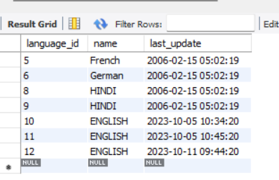

1. Create a trigger that displays a message **“The record has been inserted successfully”** whenever a record is inserted in the language table.

/*2*/

CREATE TABLE insertion_messages (

id INT AUTO_INCREMENT PRIMARY KEY,

message VARCHAR(255),

created_at TIMESTAMP DEFAULT CURRENT_TIMESTAMP

);

DELIMITER //

CREATE TRIGGER display

AFTER INSERT ON language

FOR EACH ROW

BEGIN

INSERT INTO insertion_messages (message) VALUES ('The record has been inserted successfully');

END;

//

DELIMITER ;

INSERT INTO language (name) VALUES ('english');

SELECT * FROM insertion_messages;

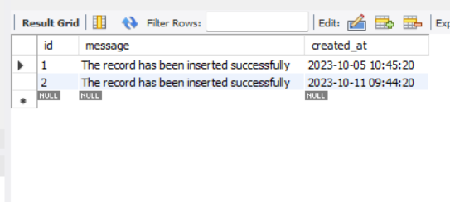

1. Create a new table **audit_language_update** with the following schema.

|  |  |
| --- | --- |
| **Column** | **Datatype and constraint** |
| language_id | TINYINT(3) |
| name | CHAR(20) |
| last_update | TIMESTAMP |
| Status | CHAR(20)    Should accept only “Before Update” and “After Update” |

For audit purpose, Create a trigger that inserts existing (old) record as well as updated record into above table whenever a record gets updated in ‘language’ table

CREATE TABLE audit_language_update (

id INT AUTO_INCREMENT PRIMARY KEY,

language_id TINYINT(3),

name CHAR(20),

last_update TIMESTAMP,

status CHAR(20)

);

DELIMITER //

CREATE TRIGGER language_audit_trigger

AFTER UPDATE ON language

FOR EACH ROW

BEGIN

-- Insert old record (BEFORE UPDATE) into audit table

INSERT INTO audit_language_update (language_id, name, last_update, status)

VALUES (OLD.language_id, OLD.name, OLD.last_update, 'Before Update');

-- Insert updated record (AFTER UPDATE) into audit table

INSERT INTO audit_language_update (language_id, name, last_update, status)

VALUES (NEW.language_id, NEW.name, NEW.last_update, 'After Update');

END;

//

DELIMITER ;

UPDATE language

SET name = 'English'

WHERE language_id = 1;

SELECT * FROM audit_language_update;

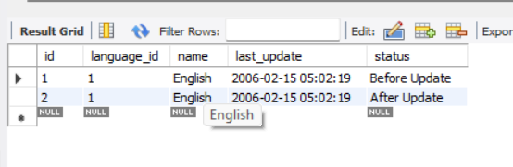

1. Create a new table **language_before_delete** with the following schema.

|  |  |
| --- | --- |
| **Column** | **Datatype and constraint** |
| language_id | TINYINT(3) |
| name | CHAR(20) |
| last_update | TIMESTAMP |
| Status | CHAR(20)  **Default:** “Before Delete” |

Create a trigger that keeps backup of deleted records into above table whenever a record is deleted in ‘language’ table

CREATE TABLE language_before_delete (

language_id TINYINT(3),

name CHAR(20),

last_update TIMESTAMP,

status CHAR(20) DEFAULT 'Before Delete'

);

DELIMITER //

CREATE TRIGGER language_delete_trigger

AFTER DELETE ON language

FOR EACH ROW

BEGIN

-- Insert deleted record into backup table

INSERT INTO language_before_delete (language_id, name, last_update)

VALUES (OLD.language_id, OLD.name, OLD.last_update);

END;

//

DELIMITER ;

DELETE FROM language WHERE language_id = 2;

SELECT * FROM language_before_delete;

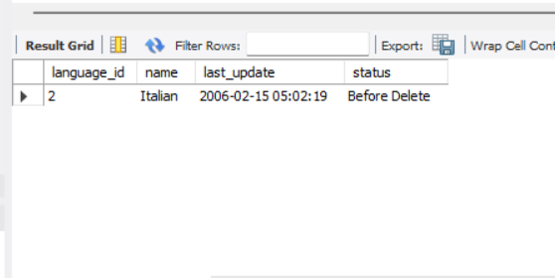

1. Create a new table **language_after_delete** with the following schema.

|  |  |
| --- | --- |
| **Column** | **Datatype and constraint** |
| language_id | TINYINT(3) |
| name | CHAR(20) |
| Status | VARCHAR(200) |

Create a trigger that maintains the status of deleted records into above table whenever a record is deleted in ‘language’ table.

Status should be displayed as: “Language ***[language_name]*** with ID ***[language_id]*** was deleted on ***[timestamp when the record was deleted]***

***-- Create the language_after_delete table***

***CREATE TABLE language_after_delete (***

***language_id TINYINT(3),***

***name CHAR(20),***

***Status VARCHAR(200)***

***);***

***-- Create the trigger to maintain deleted records in language_after_delete table***

***DELIMITER //***

***CREATE TRIGGER after_language_delete***

***AFTER DELETE ON language***

***FOR EACH ROW***

***BEGIN***

***INSERT INTO language_after_delete (language_id, name, Status)***

***VALUES (OLD.language_id, OLD.name,***

***CONCAT('Language ', OLD.name, ' with ID ', OLD.language_id, ' was deleted on ', NOW()));***

***END;***

***//***

***DELIMITER ;***

***-- Insert some sample data into the language table***

***INSERT INTO language (language_id, name) VALUES (111, 'nope ');***

***INSERT INTO language (language_id, name) VALUES (121, 'animal');***

***INSERT INTO language (language_id, name) VALUES (131, 'code');***

***DELETE FROM language WHERE language_id = 111;***

***SELECT * FROM language_after_delete;***

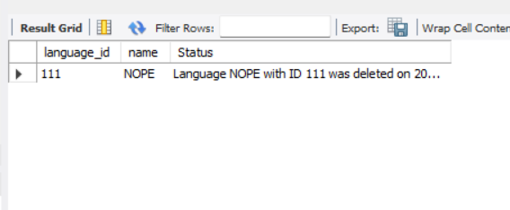

1. Display all the triggers in your database.

show triggers;

